嚴重特殊傳染性肺炎期間出國旅遊調查表暨切結書

佛光大學國際暨兩岸事務處華語教學中心學生 (學號) (姓名)於2020年6月30日前，是否有出國計畫？

□是，自2020年 月 日至2020年 月 日將前往 (國家) (城市)。
□否，2020年6月30日前我沒有出國計畫。

若是，本人於行前已了解台灣與目的地國家對「嚴重特殊傳染性肺炎」(COVID-19)防疫措施以及佛光大學就學與獎學金相關規定，非必要將避免出國，若仍決定前往，相關風險願意自行承擔。返台後悉依政府及學校相關防疫規定處理，可能造成之相關權益損失及衍生費用等一切後果由本人自負，與貴校無涉，絕無異議。

Survey and Affidavit for Travelling Abroad during COVID-19 Outbreak

To affirm that I, (Student ID: ), student of the Chinese Language Instruction Center (CLIC), Office of International and Cross-Strait Affairs, Fo Guang University, plan to travel abroad before 2020/6/30 or not.

□Yes, I will go to from 2020/__/__(MM/DD) to 2020/__/__(MM/DD).
□No, I do not have any plan of travelling abroad before 2020/6/30.

If yes, I have understood the preventive measures about COVID-19 in Taiwan and the destination country, as well as the regulations of studying and scholarship before departure. I will avoid travelling abroad unless necessary and follow the rules of the Government of Taiwan and Fo Guang University after returning. If I decide to go abroad, I am responsible for all risks, consequences and related charges such as loss of relevant equity with no objection.

Affiant’s Signature: ________________________________
Affiant’s Passport Number: _________________________
Affiant’s ARC Number: ____________________________
Date of Signing: ______/____/____(YYYY/MM/DD)

備註Note：本切結書一式二份，一份佛光大學保存，一份由學生自行留存查核。
Two original copies of this affidavit shall be provided, one kept by the Chinese Language Instruction Center, Office of International and Cross-Strait Affairs, Fo Guang University, and one kept by the student for reference.

附件

因應全球COVID-19疫情擴大，為及早發現疑似個案及防堵病毒於社區及醫療院所傳播，台灣中央流行疫情指揮中心於2020.2.16啟動加強社區監測方案，監測對象包括14天內有國外旅遊史之個案：
Taiwan Central Epidemic Command Center (CECC) indicated that in response to the expanding global outbreak of coronavirus disease COVID-19, in order to early detect suspected cases and prevent community-based and nosocomial spread, since February 16, 2020, the community-based surveillance measure has been expanded to include any individuals with foreign travel history in the past 14 days.
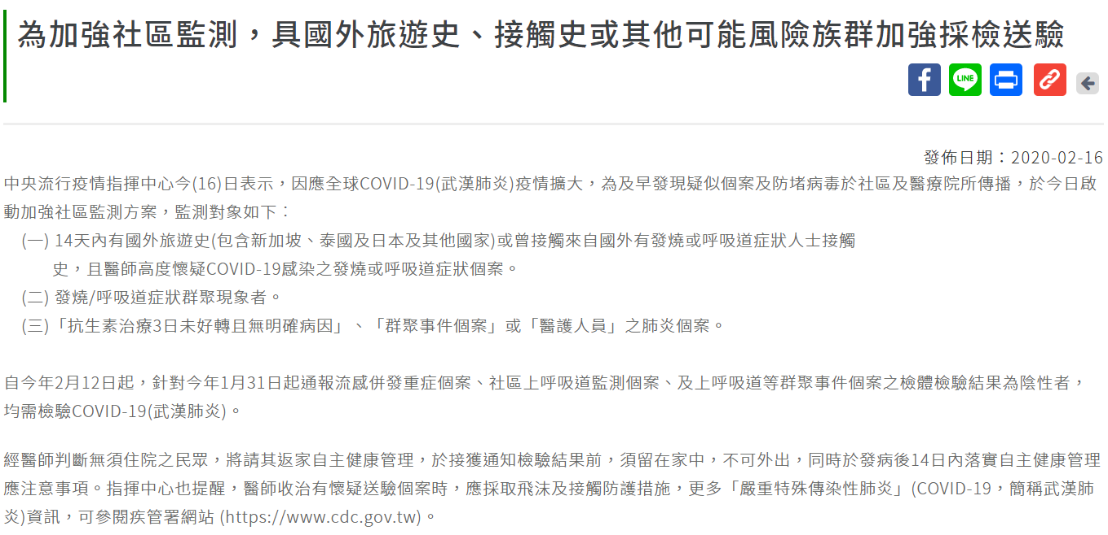

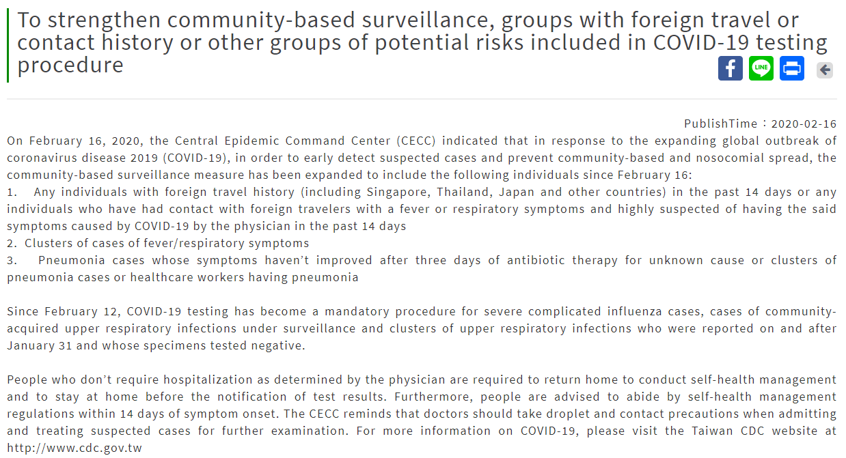
Source: 衛生福利部疾病管制署Taiwan Centers for Disease Control(https://www.cdc.gov.tw/en)

